IPC THREAD SYNCHRONIZATION
1. Synchronisation Using Mutexes
- Write a C program where multiple threads increment a shared counter using a mutex to prevent race conditions.
PROGRAM:
/*
Program to demonstrate mutex synchronization (shared counter)
Author : MUTHUGANESH S
Date : 14/03/2026
Filename : cou.c
*/

// Include necessary headers
#include <stdio.h>
#include <pthread.h>

// Shared counter variable and mutex lock
int counter = 0;
pthread_mutex_t lock;

// Function to increment the counter
void* increment(void* arg) {
for (int i = 0; i < 100000; i++) {
pthread_mutex_lock(&lock);
counter++;
pthread_mutex_unlock(&lock);
}
return NULL;
}

int main() {
pthread_t t1, t2;

pthread_mutex_init(&lock, NULL);

pthread_create(&t1, NULL, increment, NULL);
pthread_create(&t2, NULL, increment, NULL);

pthread_join(t1, NULL);
pthread_join(t2, NULL);

pthread_mutex_destroy(&lock);

printf("Final Counter Value: %d\n", counter);

return 0;
}
OUTPUT:
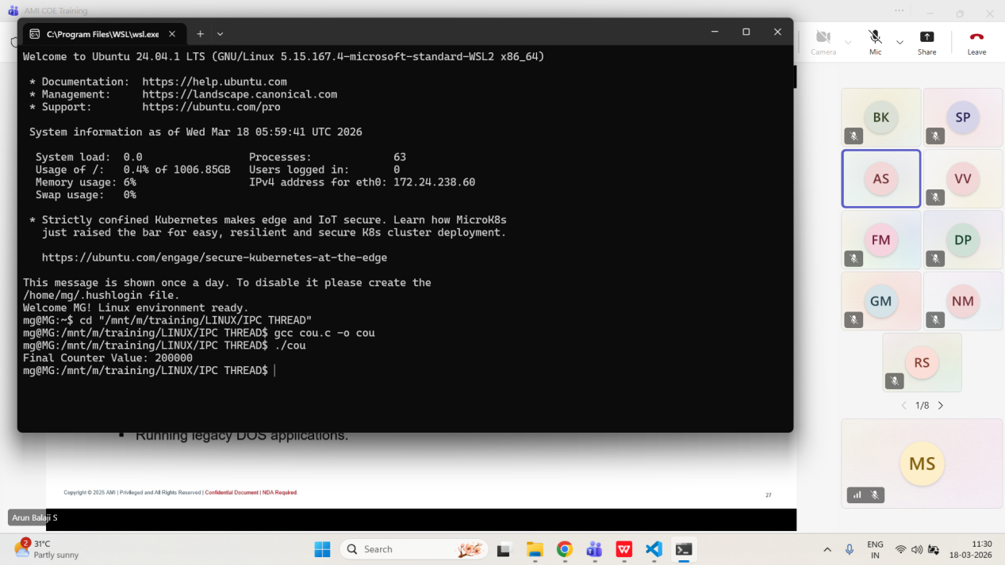
- Implement a producer-consumer problem using a mutex to synchronize access to a shared buffer.
PROGRAM:
/*
Program to demonstrate producer-consumer using mutex
Author : MUTHUGANESH S
Date : 14/03/2026
Filename : prod.c
*/

// Include necessary headers
#include <stdio.h>
#include <pthread.h>
#include <unistd.h>

// Buffer size and shared variables
#define SIZE 5

// Shared buffer and count of items in the buffer
int buffer[SIZE];
int count = 0;

// Mutex lock for synchronizing access to the buffer
pthread_mutex_t lock;

// Producer thread function
void* producer(void* arg) {
for (int i = 1; i <= 10; i++) {
pthread_mutex_lock(&lock);

if (count < SIZE) {
buffer[count++] = i;
printf("Produced: %d\n", i);
}

pthread_mutex_unlock(&lock);
sleep(1);
}
return NULL;
}

// Consumer thread function
void* consumer(void* arg) {
for (int i = 1; i <= 10; i++) {
pthread_mutex_lock(&lock);

if (count > 0) {
int item = buffer[--count];
printf("Consumed: %d\n", item);
}

pthread_mutex_unlock(&lock);
sleep(1);
}
return NULL;
}

int main() {
pthread_t p, c;

pthread_mutex_init(&lock, NULL);

pthread_create(&p, NULL, producer, NULL);
pthread_create(&c, NULL, consumer, NULL);

pthread_join(p, NULL);
pthread_join(c, NULL);

pthread_mutex_destroy(&lock);

return 0;
}

OUTPUT:
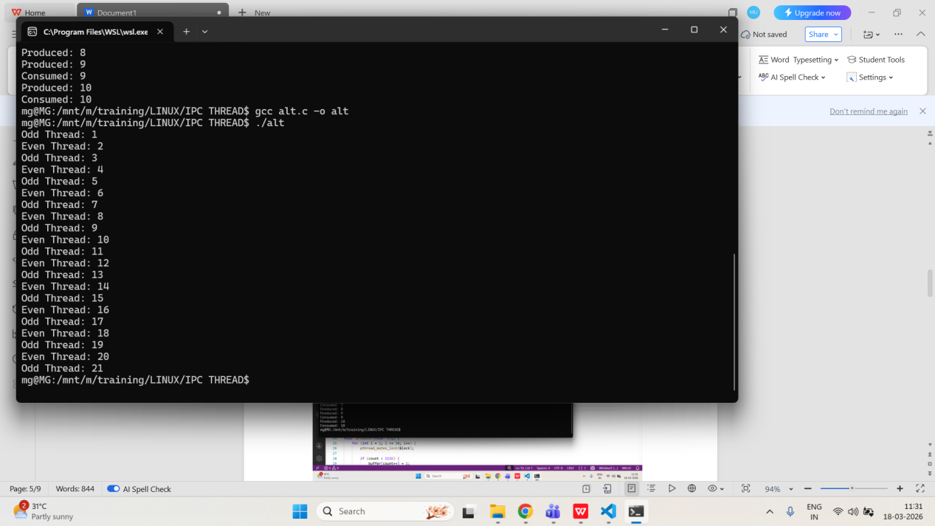
- Create a program where two threads alternately print numbers from 1 to 20, using a mutex to control access to the print operation.
PROGRAM:
/*
Program to print numbers alternately using mutex
Author : MUTHUGANESH S
Date : 14/03/2026
Filename : alt.c
*/

// Include necessary headers
#include <stdio.h>
#include <pthread.h>

// Shared variable and mutex
int num = 1;
pthread_mutex_t lock;

// Function to print odd numbers
void* printOdd(void* arg) {
while (num <= 20) {
pthread_mutex_lock(&lock);

if (num % 2 != 0) {
printf("Odd Thread: %d\n", num);
num++;
}

pthread_mutex_unlock(&lock);
}
return NULL;
}

// Function to print even numbers
void* printEven(void* arg) {
while (num <= 20) {
pthread_mutex_lock(&lock);

if (num % 2 == 0) {
printf("Even Thread: %d\n", num);
num++;
}

pthread_mutex_unlock(&lock);
}
return NULL;
}

int main() {
pthread_t t1, t2;

pthread_mutex_init(&lock, NULL);

pthread_create(&t1, NULL, printOdd, NULL);
pthread_create(&t2, NULL, printEven, NULL);

pthread_join(t1, NULL);
pthread_join(t2, NULL);

pthread_mutex_destroy(&lock);

return 0;
}

OUTPUT:
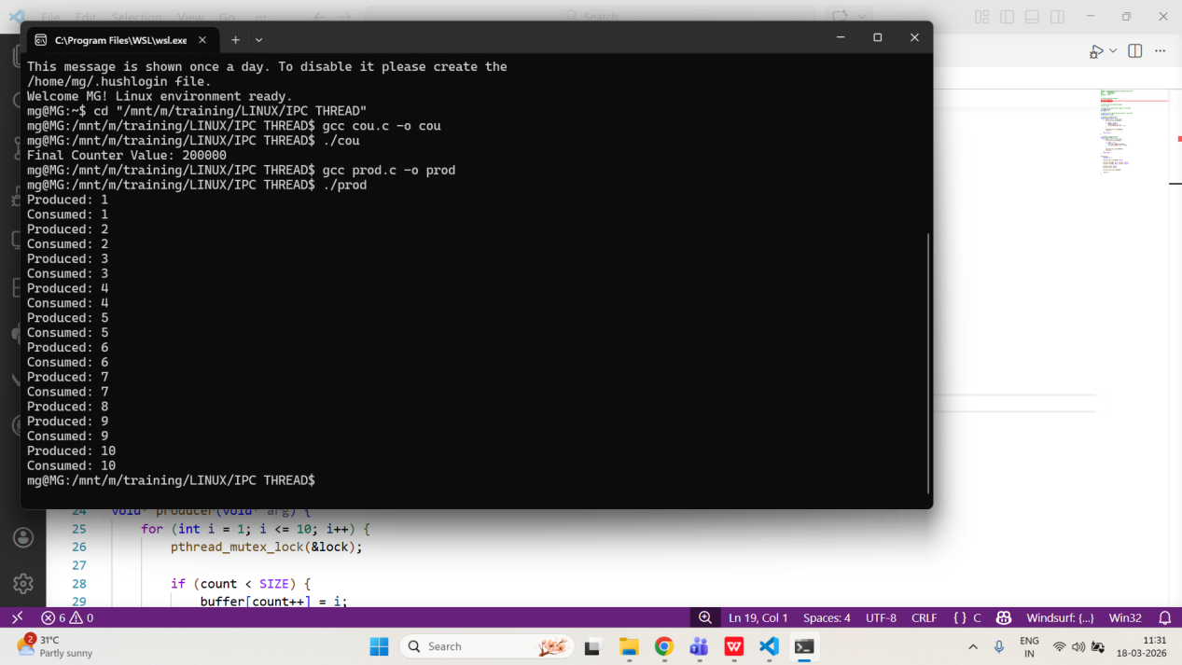

2. Synchronisation Using Conditional Variables
- Write a C program that uses a condition variable to signal a consumer thread when a producer thread adds data to a shared buffer.
PROGRAM:
/*
Program to demonstrate producer-consumer using condition variable
Author : MUTHUGANESH S
Date : 12/03/2026
Filename : pc.c
*/

// Include necessary headers
#include <stdio.h>
#include <pthread.h>
#include <unistd.h>

// Define constants for buffer size
#define SIZE 5

// Buffer and count
int buffer[SIZE];
int count = 0;

// Mutex and condition variable for synchronization
pthread_mutex_t mutex;
pthread_cond_t cond;

// Producer thread function
void* producer(void* arg) {
for (int i = 1; i <= 10; i++) {
pthread_mutex_lock(&mutex);

while (count == SIZE)
pthread_cond_wait(&cond, &mutex);

buffer[count++] = i;
printf("Produced: %d\n", i);

pthread_cond_signal(&cond);
pthread_mutex_unlock(&mutex);

sleep(1);
}
return NULL;
}

// Consumer thread function
void* consumer(void* arg) {
for (int i = 1; i <= 10; i++) {
pthread_mutex_lock(&mutex);

while (count == 0)
pthread_cond_wait(&cond, &mutex);

int item = buffer[--count];
printf("Consumed: %d\n", item);

pthread_cond_signal(&cond);
pthread_mutex_unlock(&mutex);

sleep(2);
}
return NULL;
}

// Main function
int main() {
pthread_t p, c;

pthread_mutex_init(&mutex, NULL);
pthread_cond_init(&cond, NULL);

pthread_create(&p, NULL, producer, NULL);
pthread_create(&c, NULL, consumer, NULL);

pthread_join(p, NULL);
pthread_join(c, NULL);

pthread_mutex_destroy(&mutex);
pthread_cond_destroy(&cond);

return 0;
}

OUTPUT:
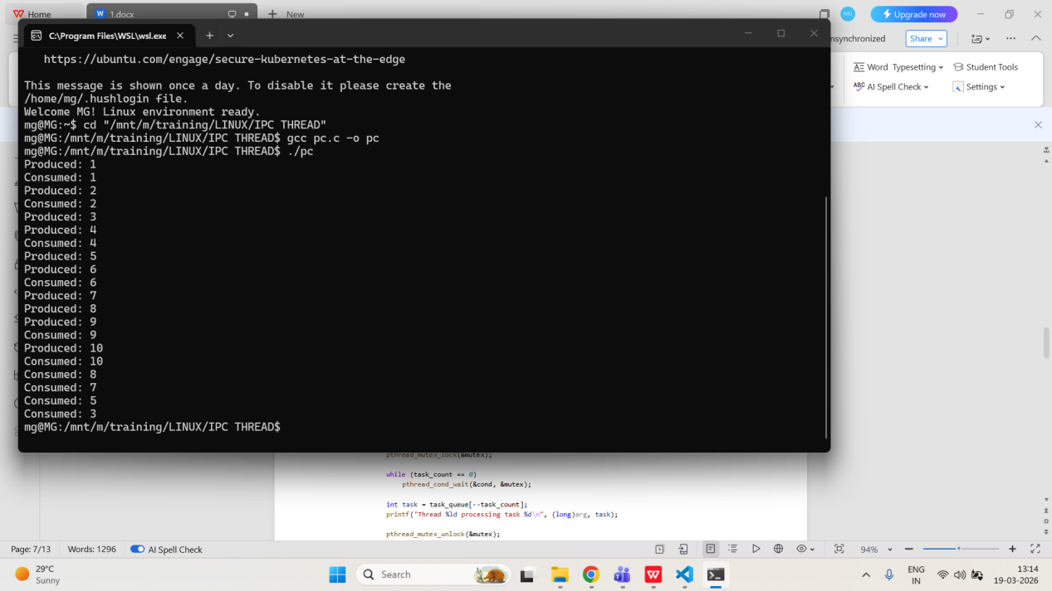

- Implement a thread pool where worker threads wait on a condition variable for new tasks.
PROGRAM:
/*
Program to demonstrate thread pool using condition variable
Author : MUTHUGANESH S
Date : 12/03/2026
Filename : tp.c
*/

// Include necessary headers
#include <stdio.h>
#include <pthread.h>
#include <unistd.h>

// Define constants for the number of threads and tasks
#define THREADS 3
#define TASKS 5

// Task queue and count
int task_queue[TASKS];
int task_count = 0;

// Mutex and condition variable for synchronization
pthread_mutex_t mutex;
pthread_cond_t cond;

// Worker thread function
void* worker(void* arg) {
while (1) {
pthread_mutex_lock(&mutex);

while (task_count == 0)
pthread_cond_wait(&cond, &mutex);

int task = task_queue[--task_count];
printf("Thread %ld processing task %d\n", (long)arg, task);

pthread_mutex_unlock(&mutex);

sleep(1);
}
return NULL;
}

int main() {
pthread_t workers[THREADS];

pthread_mutex_init(&mutex, NULL);
pthread_cond_init(&cond, NULL);

for (long i = 0; i < THREADS; i++)
pthread_create(&workers[i], NULL, worker, (void*)i);

for (int i = 1; i <= TASKS; i++) {
pthread_mutex_lock(&mutex);

task_queue[task_count++] = i;
printf("Added task %d\n", i);

pthread_cond_signal(&cond);
pthread_mutex_unlock(&mutex);

sleep(1);
}

sleep(5);
return 0;
}
OUTPUT:
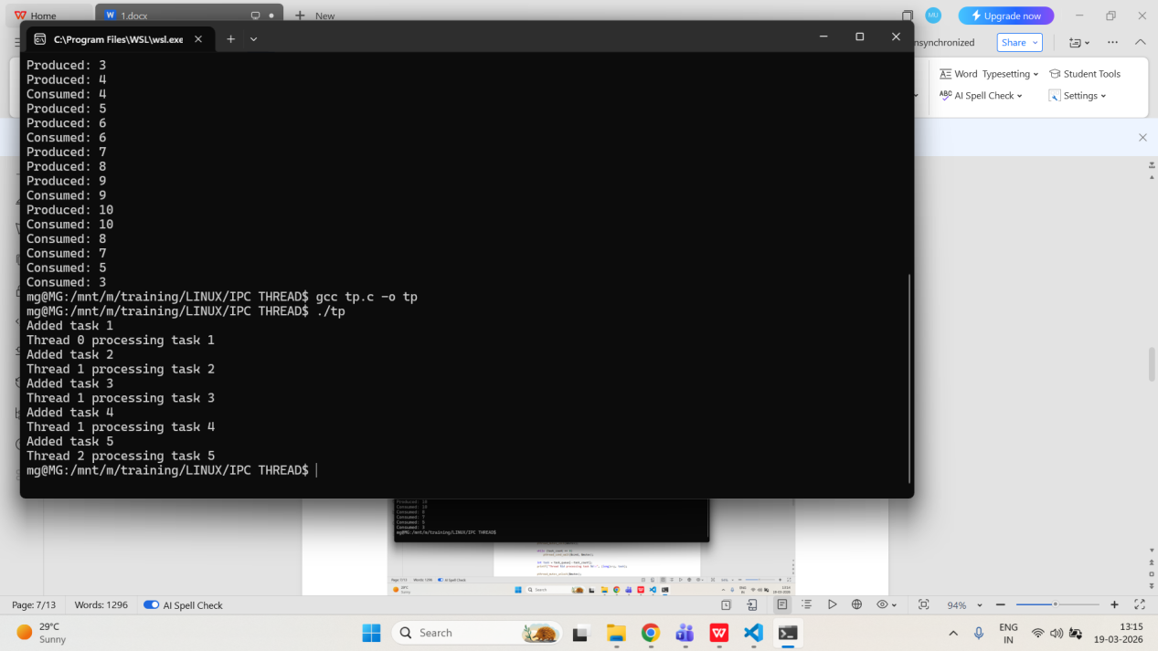

- Create a program where one thread waits for a specific condition (e.g., counter reaches 10) before proceeding, using a condition variable for synchronization.
PROGRAM:
/*
Program to demonstrate waiting for a condition using condition variable
Author : MUTHUGANESH S
Date : 12/03/2026
Filename : cw.c
*/

// Include necessary headers
#include <stdio.h>
#include <pthread.h>
#include <unistd.h>

// Shared counter variable
int counter = 0;

// Mutex and condition variable for synchronization
pthread_mutex_t mutex;
pthread_cond_t cond;

// Incrementer thread function
void* incrementer(void* arg) {
for (int i = 0; i < 10; i++) {
pthread_mutex_lock(&mutex);

counter++;
printf("Counter: %d\n", counter);

if (counter == 10)
pthread_cond_signal(&cond);

pthread_mutex_unlock(&mutex);
sleep(1);
}
return NULL;
}

// Waiter thread function
void* waiter(void* arg) {
pthread_mutex_lock(&mutex);

while (counter < 10)
pthread_cond_wait(&cond, &mutex);

printf("Counter reached 10. Proceeding...\n");

pthread_mutex_unlock(&mutex);
return NULL;
}

int main() {
pthread_t t1, t2;

pthread_mutex_init(&mutex, NULL);
pthread_cond_init(&cond, NULL);

pthread_create(&t1, NULL, incrementer, NULL);
pthread_create(&t2, NULL, waiter, NULL);

pthread_join(t1, NULL);
pthread_join(t2, NULL);

pthread_mutex_destroy(&mutex);
pthread_cond_destroy(&cond);

return 0;
}
OUTPUT:
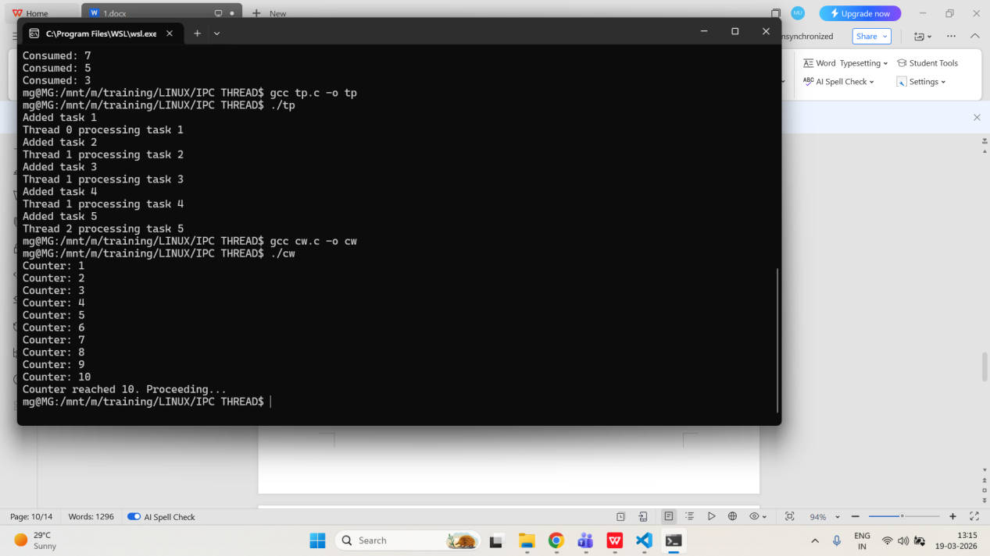

3. IPC - Unnamed Pipes
- Write a C program where a parent process sends a string to its child process using an unnamed pipe.
PROGRAM:
/*
Program to demonstrate parent to child communication using unnamed pipe
Author : MUTHUGANESH S
Date : 12/03/2026
Filename : ppc.c
*/

// Include necessary header files
#include <stdio.h>
#include <unistd.h>
#include <string.h>

int main() {
int fd[2];
pid_t pid;
char write_msg[] = "Hello from parent!";
char read_msg[50];

// Create a pipe
pipe(fd);
// Fork the process
pid = fork();

if (pid > 0) {
close(fd[0]);
write(fd[1], write_msg, strlen(write_msg) + 1);
close(fd[1]);
} else {
close(fd[1]);
read(fd[0], read_msg, sizeof(read_msg));
printf("Child received: %s\n", read_msg);
close(fd[0]);
}

return 0;
}

OUTPUT:
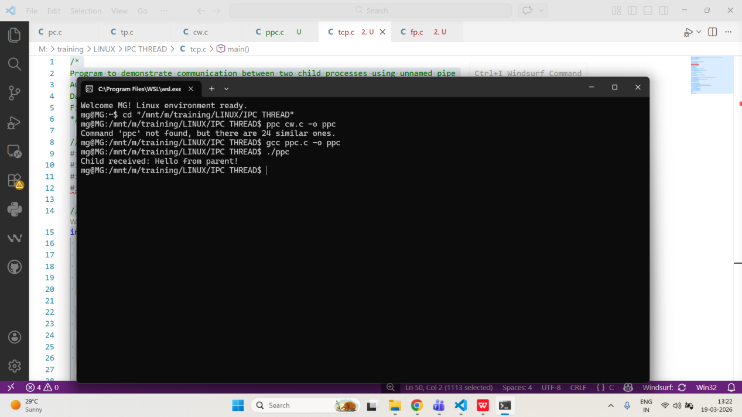
- Implement a program where two child processes communicate through an unnamed pipe created by their parent.
PROGRAM:
/*
Program to demonstrate communication between two child processes using unnamed pipe
Author : MUTHUGANESH S
Date : 12/03/2026
Filename : tcp.c
*/

// Include necessary header files
#include <stdio.h>
#include <unistd.h>
#include <string.h>
#include <sys/wait.h>

// Main function
int main() {
int fd[2];
// Create two child processes
pid_t c1, c2;
char msg[] = "Message from Child 1";
char buffer[100];

// Create an unnamed pipe
pipe(fd);

// Fork the first child process
c1 = fork();

// Check if the first child process is created successfully
if (c1 == 0) {
close(fd[0]);
write(fd[1], msg, strlen(msg) + 1);
close(fd[1]);
} else {
c2 = fork();

if (c2 == 0) {
close(fd[1]);
read(fd[0], buffer, sizeof(buffer));
printf("Child 2 received: %s\n", buffer);
close(fd[0]);
} else {
close(fd[0]);
close(fd[1]);
wait(NULL);
wait(NULL);
}
}

return 0;
}
OUTPUT:
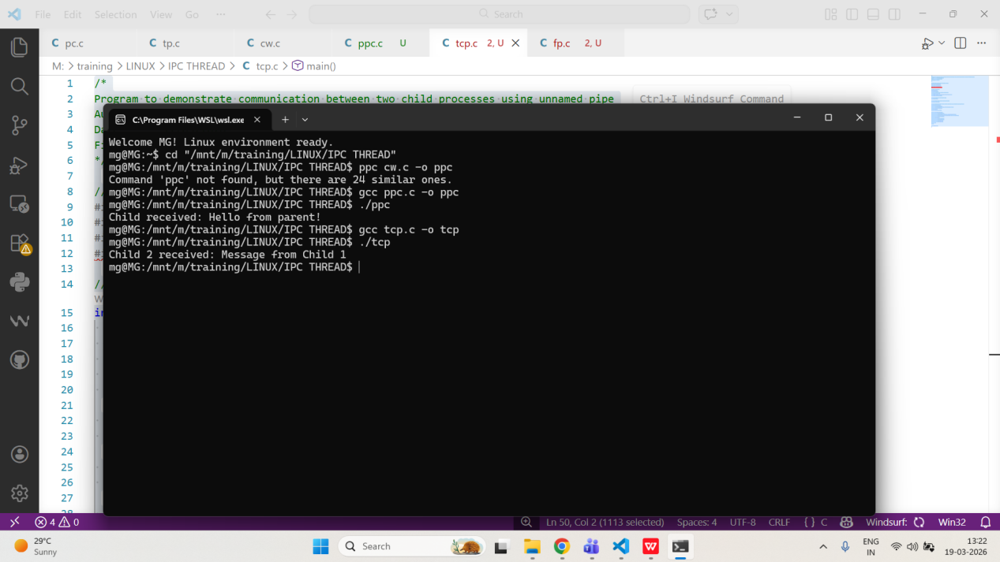
- Create a program that uses an unnamed pipe to transfer the contents of a file from one process to another.
PROGRAM:
/*
Program to transfer file contents using unnamed pipe
Author : MUTHUGANESH S
Date : 12/03/2026
Filename : fp.c
*/

// Include necessary header files
#include <stdio.h>
#include <unistd.h>
#include <fcntl.h>
#include <sys/wait.h>

int main() {
int fd[2];
pid_t pid;
char buffer[100];
int n;

pipe(fd);
pid = fork();

if (pid > 0) {
int file = open("input.txt", O_RDONLY);

close(fd[0]);

while ((n = read(file, buffer, sizeof(buffer))) > 0) {
write(fd[1], buffer, n);
}

close(file);
close(fd[1]);
wait(NULL);
} else {
int file = open("output.txt", O_WRONLY | O_CREAT | O_TRUNC, 0644);

close(fd[1]);

while ((n = read(fd[0], buffer, sizeof(buffer))) > 0) {
write(file, buffer, n);
}

close(file);
close(fd[0]);
}

return 0;
}
OUTPUT:
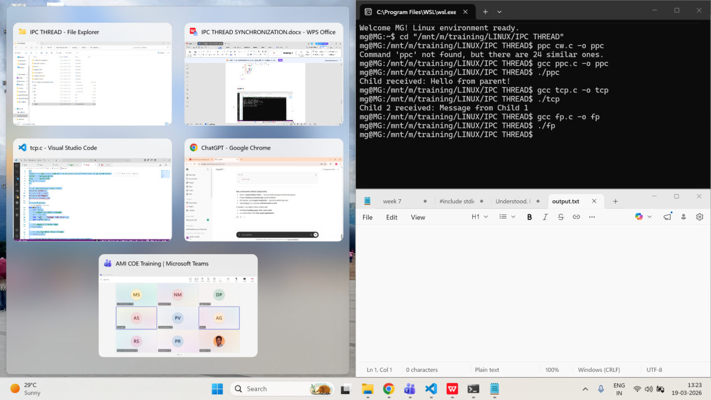

4. IPC - Named Pipes
- Write a C program that creates a named pipe (FIFO) and uses it for communication between two unrelated processes.
PROGRAM:
/*
Program to demonstrate FIFO communication (Client)
Author : MUTHUGANESH S
Date : 13/03/2026
Filename : fifo_client.c
*/

//Header files
#include <stdio.h>
#include <fcntl.h>
#include <unistd.h>

int main() {
int fd;
char message[] = "Hello from client";

//Open the FIFO for writing
fd = open("myfifo", O_WRONLY);

write(fd, message, sizeof(message));

close(fd);

return 0;
}
/*
Program to demonstrate FIFO communication (Server)
Author : MUTHUGANESH S
Date : 13/03/2026
Filename : fifo_server.c
*/

//Header files
#include <stdio.h>
#include <sys/types.h>
#include <sys/stat.h>
#include <fcntl.h>
#include <unistd.h>

int main() {
int fd;
char buffer[100];

//Create the FIFO (named pipe)
mkfifo("myfifo", 0666);

fd = open("myfifo", O_RDONLY);

read(fd, buffer, sizeof(buffer));
printf("Received: %s\n", buffer);

close(fd);

return 0;
}
OUTPUT:
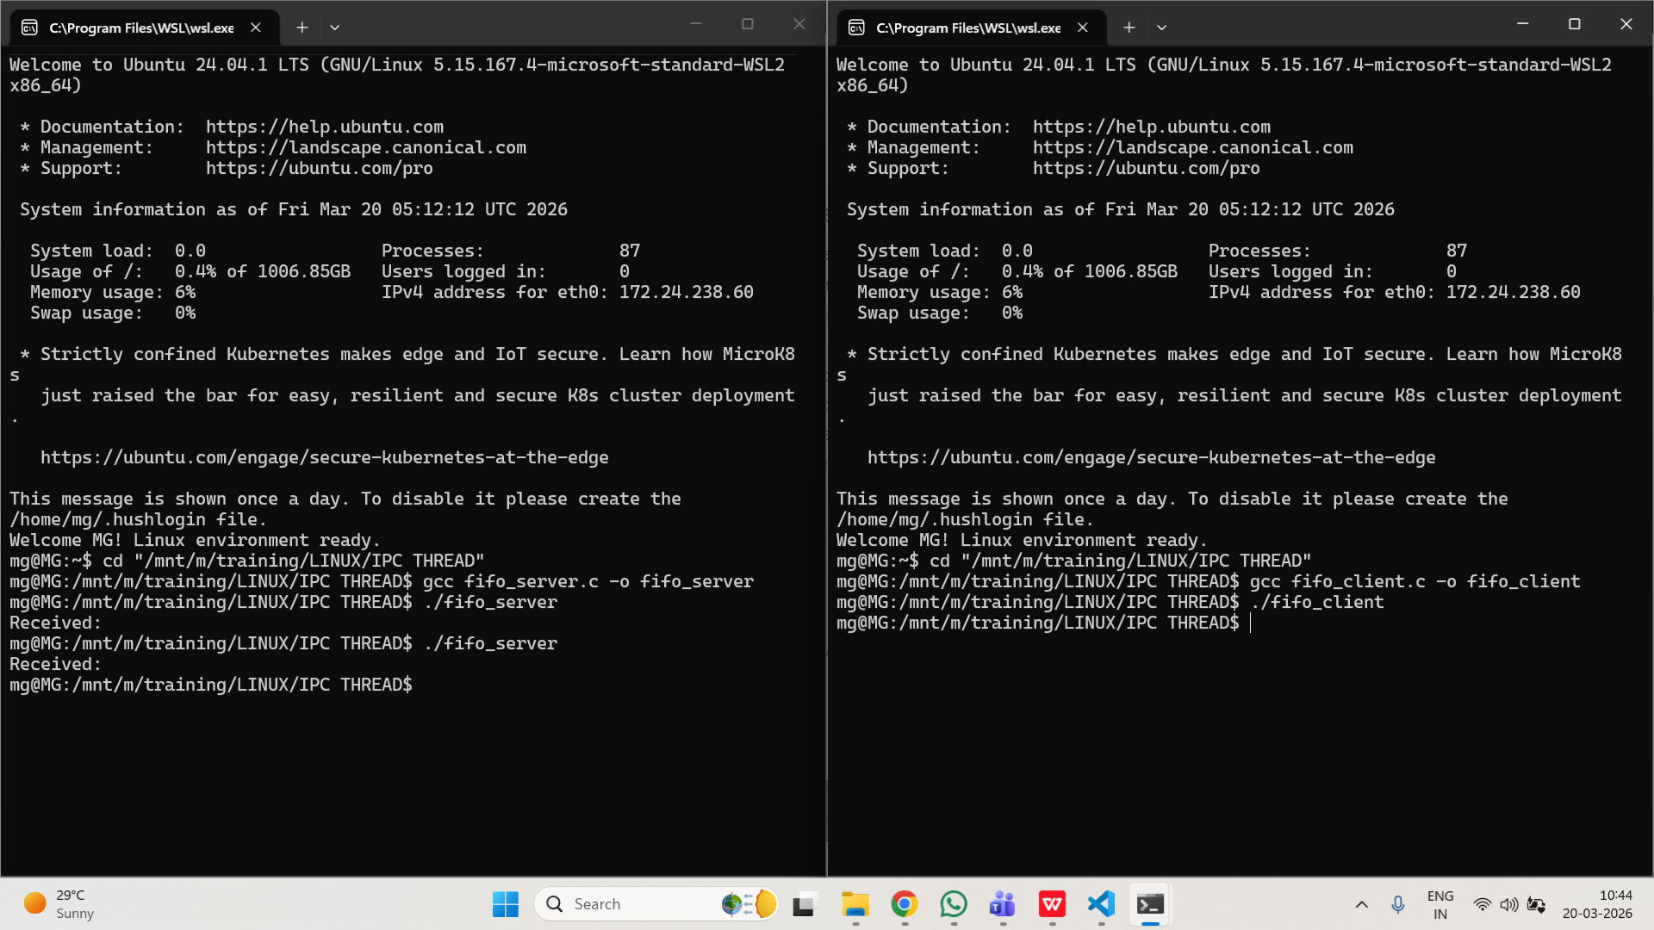
- Implement a client-server model using named pipes, where the client sends requests and the server responds.
PROGRAM:
/*
Program to demonstrate FIFO Client-Server (Client)
Author : MUTHUGANESH S
Date : 13/03/2026
Filename : cs_client.c
*/

#include <stdio.h>
#include <unistd.h>
#include <fcntl.h>

int main() {
int fd1, fd2;
char request[] = "Hello Server";
char response[100];

fd1 = open("req_fifo", O_WRONLY);
write(fd1, request, sizeof(request));

fd2 = open("res_fifo", O_RDONLY);
read(fd2, response, sizeof(response));

printf("Server Response: %s\n", response);

close(fd1);
close(fd2);

return 0;
}
/*
Program to demonstrate FIFO Client-Server (Server)
Author : MUTHUGANESH S
Date : 13/03/2026
Filename : cs_server.c
*/

#include <stdio.h>
#include <unistd.h>
#include <fcntl.h>
#include <sys/stat.h>
#include <string.h>

int main() {
int fd1, fd2;
char request[100], response[100];

mkfifo("req_fifo", 0666);
mkfifo("res_fifo", 0666);

fd1 = open("req_fifo", O_RDONLY);
read(fd1, request, sizeof(request));

printf("Client Request: %s\n", request);

sprintf(response, "Processed: %s", request);

fd2 = open("res_fifo", O_WRONLY);
write(fd2, response, sizeof(response));

close(fd1);
close(fd2);

return 0;
}

OUTPUT:
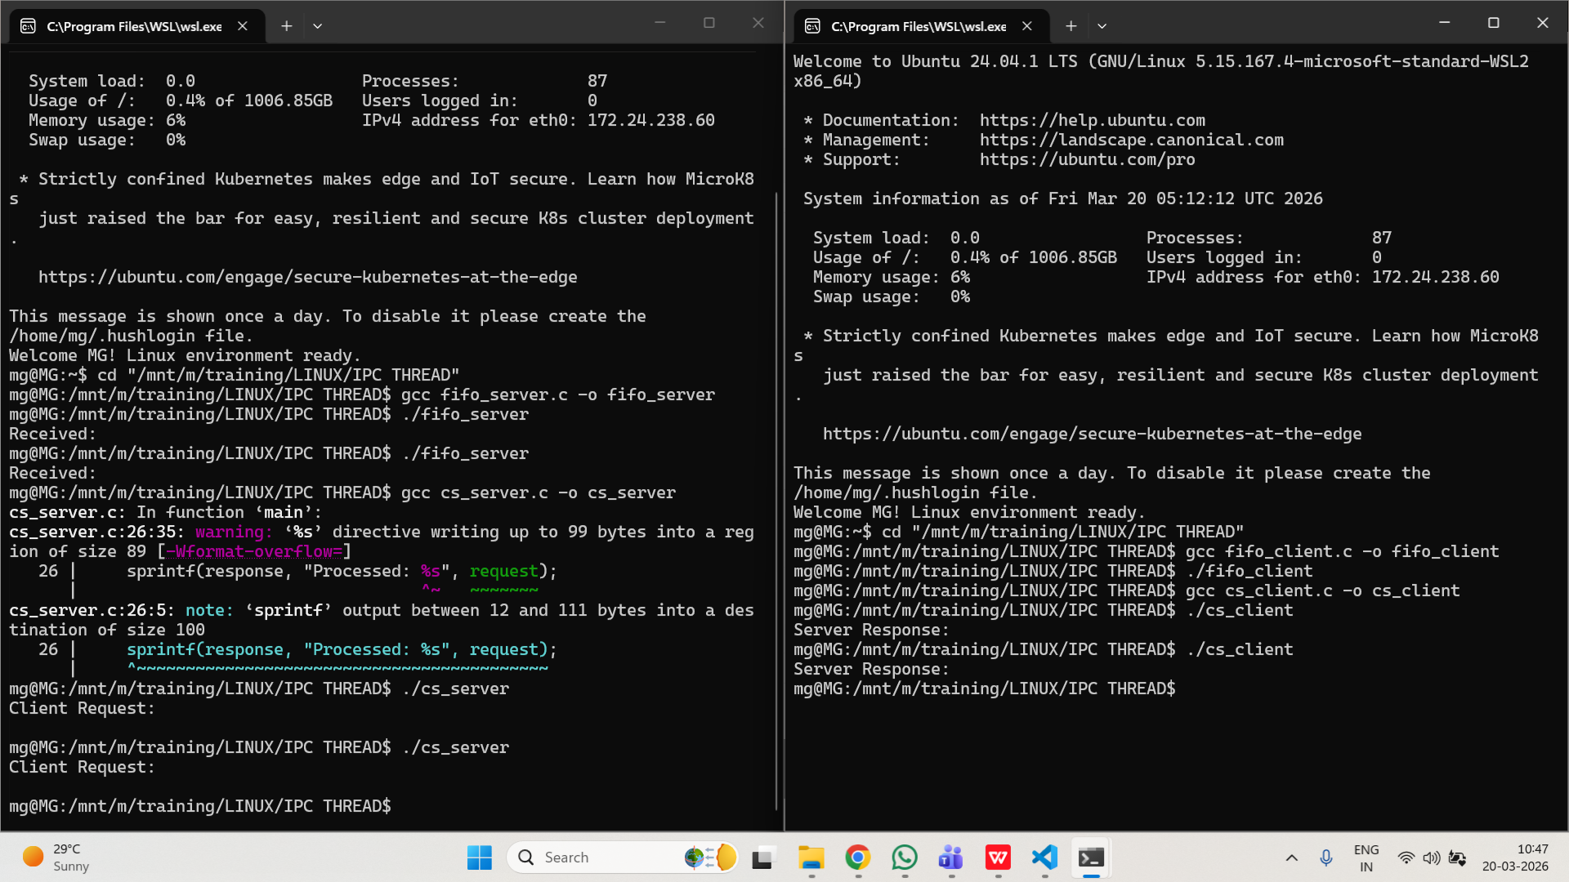

- Create a program that writes log messages to a named pipe, which are read and displayed by a separate process.
PROGRAM:
/*
Program to write logs to FIFO
Author : MUTHUGANESH S
Date : 13/03/2026
Filename : writer.c
*/
#include <stdio.h>
#include <unistd.h>
#include <fcntl.h>
#include <sys/stat.h>

int main() {
int fd;
int i = 1;
char log[100];
mkfifo("logfifo", 0666);
fd = open("logfifo", O_WRONLY);

while (1) {
sprintf(log, "Log message %d\n", i++);
write(fd, log, sizeof(log));
sleep(1);
}

close(fd);

return 0;
}
/*
Program to read logs from FIFO
Author : MUTHUGANESH S
Date : 13/03/2026
Filename : reader.c
*/

#include <stdio.h>
#include <unistd.h>
#include <fcntl.h>

int main() {
int fd;
char buffer[100];

fd = open("logfifo", O_RDONLY);

while (1) {
read(fd, buffer, sizeof(buffer));
printf("Received Log: %s", buffer);
}
close(fd);
return 0;
}
OUTPUT:
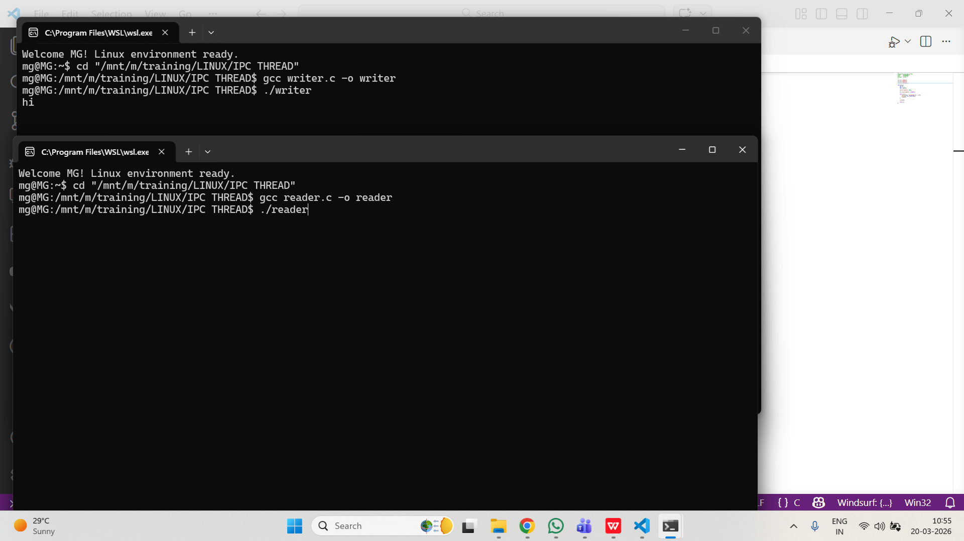
5. IPC - Message Queues
- Write a C program that creates a System V message queue and sends messages between two processes.
PROGRAM:
/*
Program to demonstrate message queue (Receiver)
Author : MUTHUGANESH S
Date : 13/03/2026
Filename : msgr.c
*/

// Header files
#include <stdio.h>
#include <sys/ipc.h>
#include <sys/msg.h>

// Structure for message queue
struct msgbuf {
long mtype;
char mtext[100];
};

int main() {
int msgid;
struct msgbuf message;

key_t key = ftok("msgfile", 65);

msgid = msgget(key, 0666 | IPC_CREAT);

msgrcv(msgid, &message, sizeof(message.mtext), 1, 0);

printf("Received: %s\n", message.mtext);

msgctl(msgid, IPC_RMID, NULL);

return 0;
}
/*
Program to demonstrate message queue (Sender)
Author : MUTHUGANESH S
Date : 13/03/2026
Filename : msgs.c
*/

// Include necessary header files
#include <stdio.h>
#include <sys/ipc.h>
#include <sys/msg.h>
#include <string.h>

// Define the structure for the message buffer
struct msgbuf {
long mtype;
char mtext[100];
};

int main() {
int msgid;
struct msgbuf message;

key_t key = ftok("msgfile", 65);

msgid = msgget(key, 0666 | IPC_CREAT);

message.mtype = 1;
strcpy(message.mtext, "Hello from sender");

msgsnd(msgid, &message, sizeof(message.mtext), 0);

printf("Message sent\n");

return 0;
}
OUTPUT:
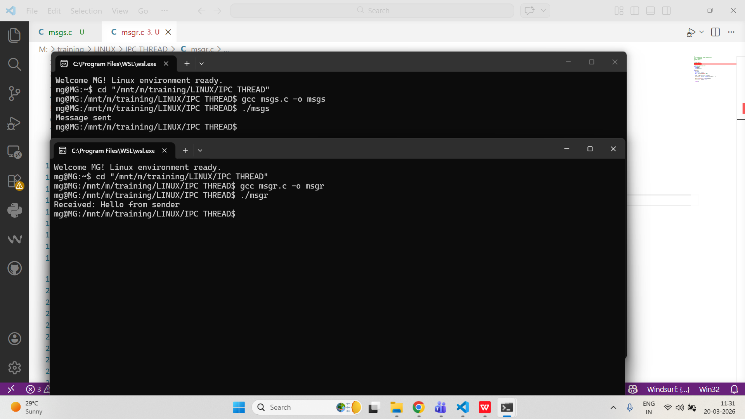
- Implement a program where multiple clients send messages to a server process using a message queue, and the server processes them in order.
PROGRAM:
/*
Program for multiple clients to server (Server)
Author : MUTHUGANESH S
Date : 13/03/2026
Filename : mqs.c
*/

//Header files
#include <stdio.h>
#include <sys/ipc.h>
#include <sys/msg.h>

//Message buffer structure
struct msgbuf {
long mtype;
char mtext[100];
};

int main() {
int msgid;
struct msgbuf message;

//Generate unique key
key_t key = ftok("msgfile", 75);

//Create message queue and get its identifier
msgid = msgget(key, 0666 | IPC_CREAT);

while (1) {
msgrcv(msgid, &message, sizeof(message.mtext), 1, 0);
printf("Received from client: %s\n", message.mtext);
}

return 0;
}
/*
Program for multiple clients to server (Client)
Author : MUTHUGANESH S
Date : 13/03/2026
Filename : mqc.c
*/

//Header files
#include <stdio.h>
#include <sys/ipc.h>
#include <sys/msg.h>
#include <string.h>

//Message buffer structure
struct msgbuf {
long mtype;
char mtext[100];
};

int main() {
int msgid;
struct msgbuf message;

key_t key = ftok("msgfile", 75);

msgid = msgget(key, 0666 | IPC_CREAT);

message.mtype = 1;

printf("Enter message: ");
fgets(message.mtext, sizeof(message.mtext), stdin);

msgsnd(msgid, &message, sizeof(message.mtext), 0);

return 0;
}
OUTPUT:
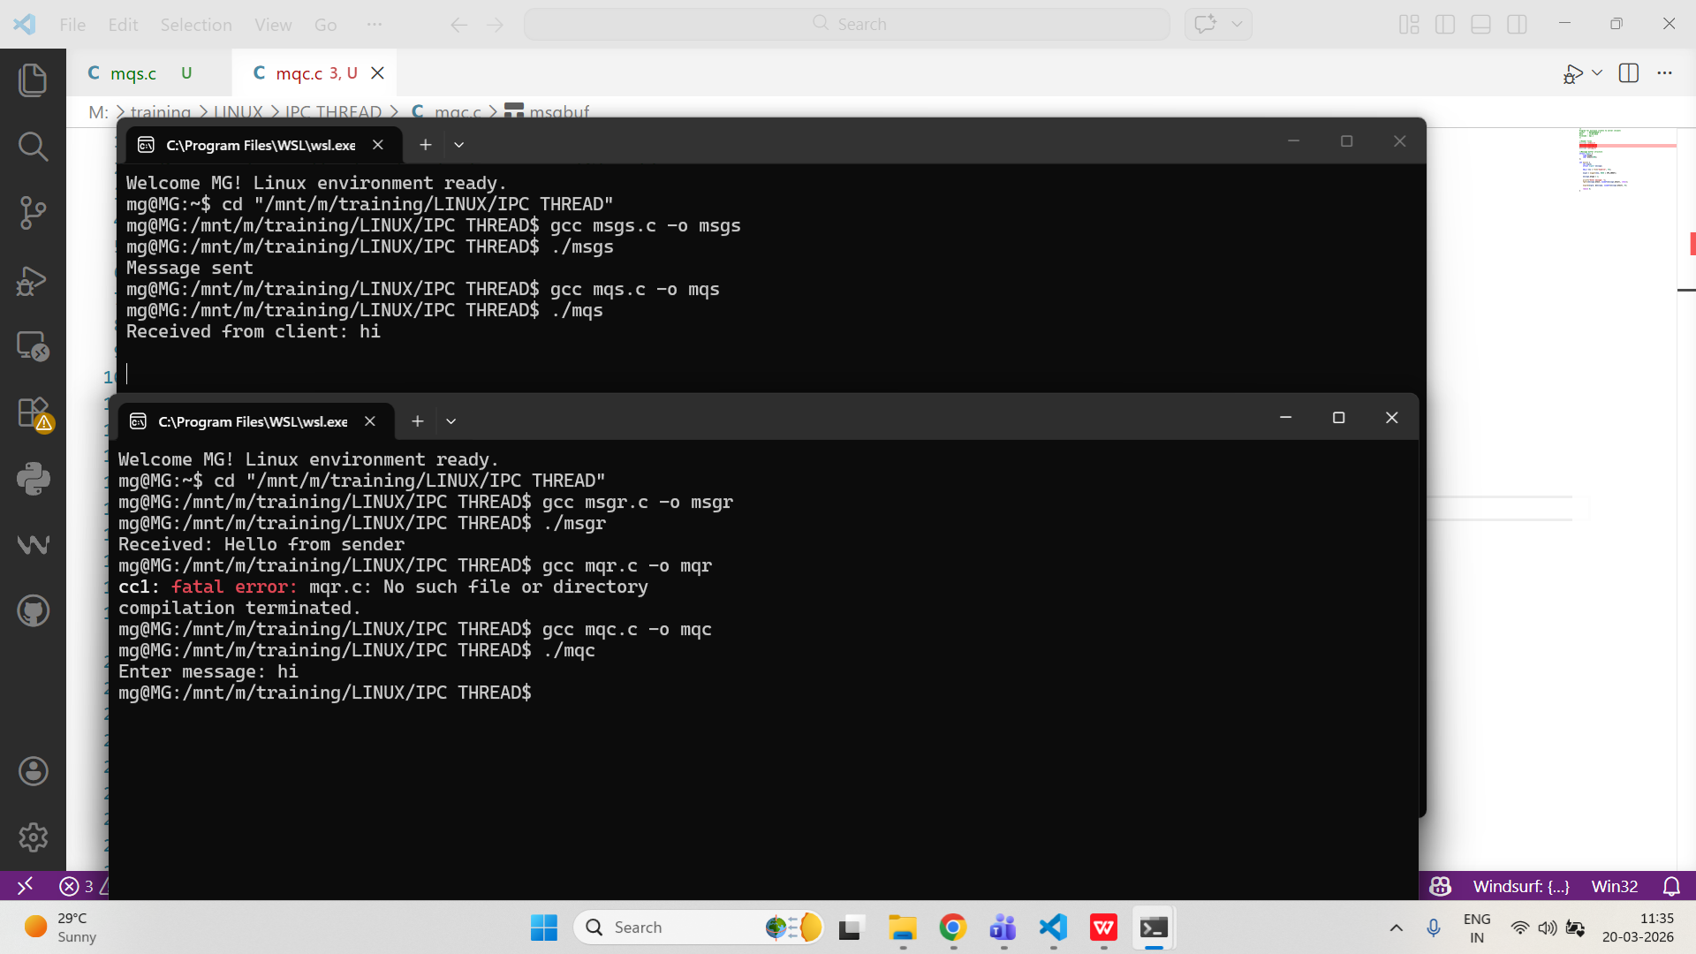

- Create a program that demonstrates message queue attributes, such as maximum message size and queue length.
PROGRAM:
/*
Program to display message queue attributes
Author : MUTHUGANESH S
Date : 13/03/2026
Filename : mqa.c
*/

//Header files
#include <stdio.h>
#include <sys/ipc.h>
#include <sys/msg.h>

int main() {
int msgid;
struct msqid_ds buf;

//Generate unique key
key_t key = ftok("msgfile", 90);

msgid = msgget(key, 0666 | IPC_CREAT);

msgctl(msgid, IPC_STAT, &buf);

printf("Maximum bytes allowed: %ld\n", buf.msg_qbytes);
printf("Current messages in queue: %ld\n", buf.msg_qnum);
printf("Last send PID: %d\n", buf.msg_lspid);
printf("Last receive PID: %d\n", buf.msg_lrpid);

return 0;
}
OUTPUT:
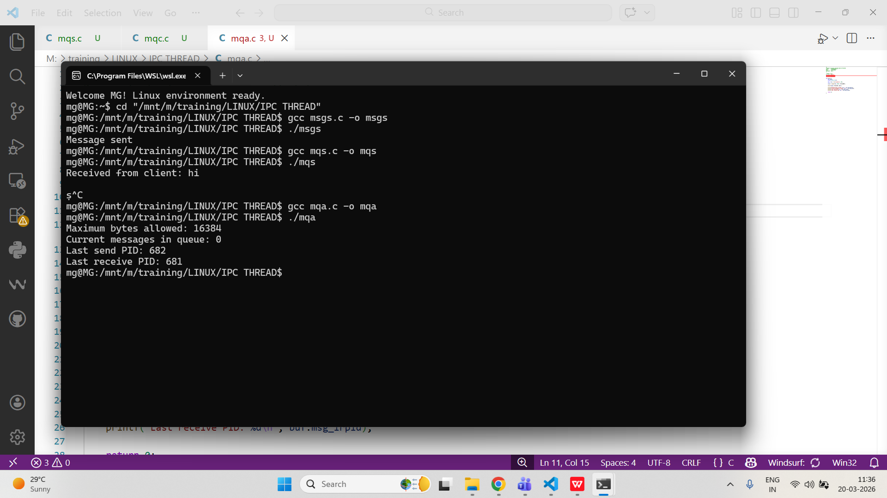
6. Shared Memory
- Write a C program that creates a shared memory segment and allows two processes to exchange data through it.
PROGRAM:
/*
Program to demonstrate shared memory (Reader)
Author : MUTHUGANESH S
Date : 13/03/2026
Filename : shmr.c
*/

//Header files
#include <stdio.h>
#include <sys/ipc.h>
#include <sys/shm.h>

int main() {
int shmid;
char *str;

//Generate unique key
key_t key = ftok("shmfile", 65);

//Create shared memory segment
shmid = shmget(key, 1024, 0666 | IPC_CREAT);

str = (char*) shmat(shmid, NULL, 0);

printf("Data read from memory: %s\n", str);

shmdt(str);

shmctl(shmid, IPC_RMID, NULL);

return 0;
}
/*
Program to demonstrate shared memory (Writer)
Author : MUTHUGANESH S
Date : 13/03/2026
Filename : shmw.c
*/

//Header files
#include <stdio.h>
#include <sys/ipc.h>
#include <sys/shm.h>
#include <string.h>

int main() {
int shmid;
char *str;

key_t key = ftok("shmfile", 65);

//Create shared memory segment
shmid = shmget(key, 1024, 0666 | IPC_CREAT);

str = (char*) shmat(shmid, NULL, 0);

printf("Write Data: ");
fgets(str, 100, stdin);

printf("Data written to memory\n");

return 0;
}
OUTPUT:
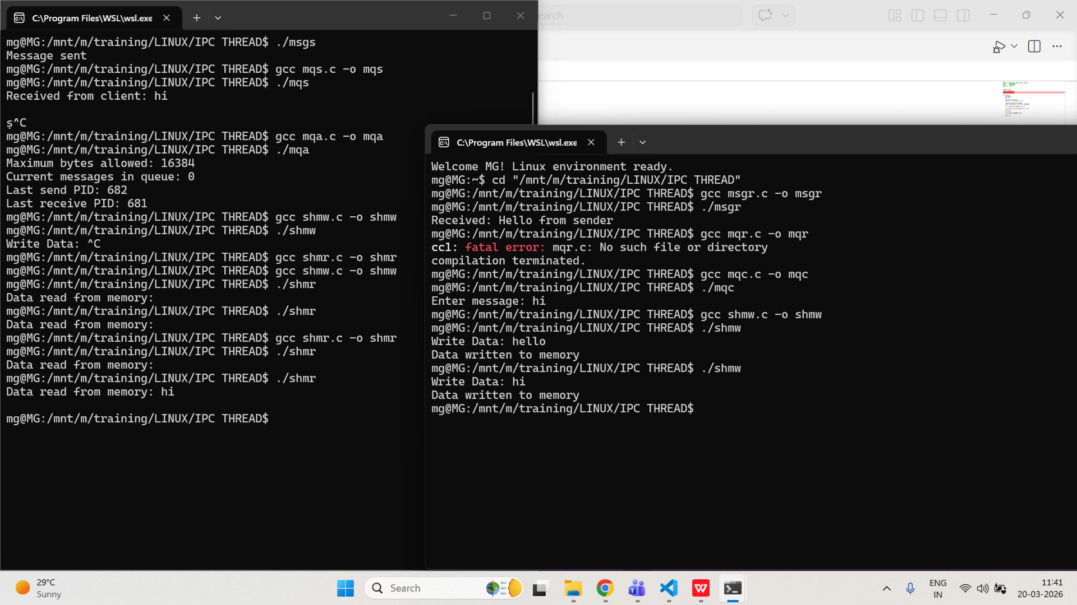
- Implement a producer-consumer problem using shared memory for the buffer and semaphores for synchronization.
PROGRAM:
/*
Program for producer using shared memory + semaphore
Author : MUTHUGANESH S
Date : 13/03/2026
Filename : pro.c
*/

#include <stdio.h>
#include <sys/ipc.h>
#include <sys/shm.h>
#include <semaphore.h>
#include <fcntl.h>
#include <unistd.h>

int main() {
int shmid;
int *buffer;

key_t key = ftok("shmfile", 75);
shmid = shmget(key, sizeof(int), 0666 | IPC_CREAT);

buffer = (int*) shmat(shmid, NULL, 0);

sem_t *sem = sem_open("sem", O_CREAT, 0666, 1);

for (int i = 1; i <= 5; i++) {
sem_wait(sem);

*buffer = i;
printf("Produced: %d\n", i);

sleep(1);

sem_post(sem);
}

return 0;
}
/*
Program for consumer using shared memory + semaphore
Author : MUTHUGANESH S
Date : 13/03/2026
Filename : con.c
*/

//Header files
#include <stdio.h>
#include <sys/ipc.h>
#include <sys/shm.h>
#include <semaphore.h>
#include <fcntl.h>
#include <unistd.h>

int main() {
int shmid;
int *buffer;

key_t key = ftok("shmfile", 75);
shmid = shmget(key, sizeof(int), 0666 | IPC_CREAT);

buffer = (int*) shmat(shmid, NULL, 0);

sem_t *sem = sem_open("sem", 0);

for (int i = 1; i <= 5; i++) {
sem_wait(sem);

printf("Consumed: %d\n", *buffer);

sleep(1);

sem_post(sem);
}

return 0;
}
OUTPUT:
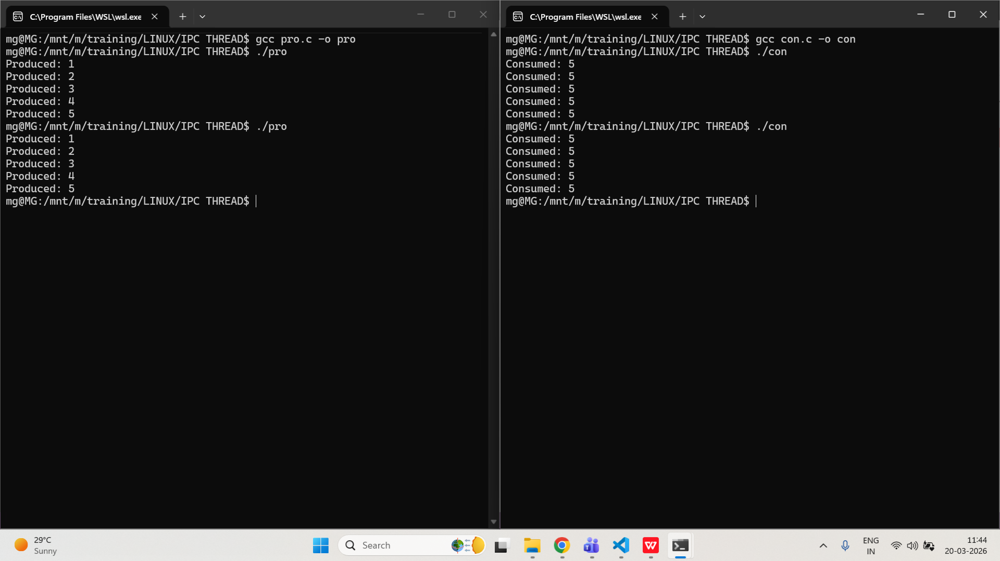
- Create a program that demonstrates how to attach, detach, and remove a shared memory segment.
PROGRAM:
/*
Program to demonstrate attach, detach, remove shared memory
Author : MUTHUGANESH S
Date : 13/03/2026
Filename : shm.c
*/

//Header files
#include <stdio.h>
#include <sys/ipc.h>
#include <sys/shm.h>

int main() {
int shmid;
char *ptr;

key_t key = ftok("shmfile", 90);

// Create shared memory segment
shmid = shmget(key, 1024, 0666 | IPC_CREAT);

ptr = (char*) shmat(shmid, NULL, 0);

printf("Attached shared memory\n");

sprintf(ptr, "Test Message");

printf("Data: %s\n", ptr);

shmdt(ptr);
printf("Detached shared memory\n");

shmctl(shmid, IPC_RMID, NULL);
printf("Removed shared memory\n");

return 0;
}
OUTPUT:
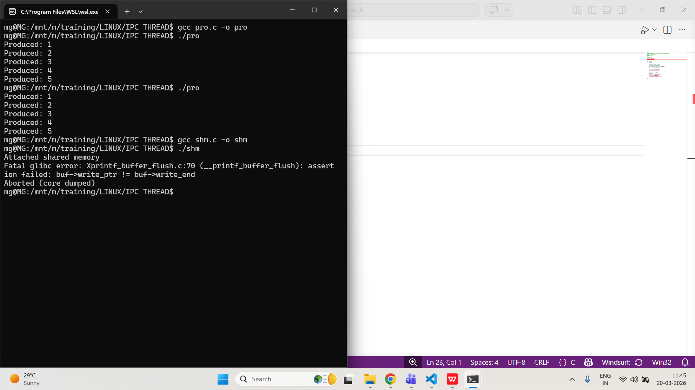

7. Semaphores
- Write a C program that uses POSIX semaphores to synchronize access to a shared resource among multiple processes.
PROGRAM:
/*
Program to synchronize shared resource using POSIX semaphore
Author : MUTHUGANESH S
Date : 13/03/2026
Filename : sync.c
*/

//Header files
#include <stdio.h>
#include <semaphore.h>
#include <fcntl.h>
#include <unistd.h>

int main() {
sem_t *sem;

// Create or open a named semaphore
sem = sem_open("mysem", O_CREAT, 0666, 1);

printf("Waiting to enter critical section...\n");
sem_wait(sem);
printf("Entered critical section\n");
sleep(3);
printf("Exiting critical section\n");
sem_post(sem);
sem_close(sem);
return 0;
}
OUTPUT:
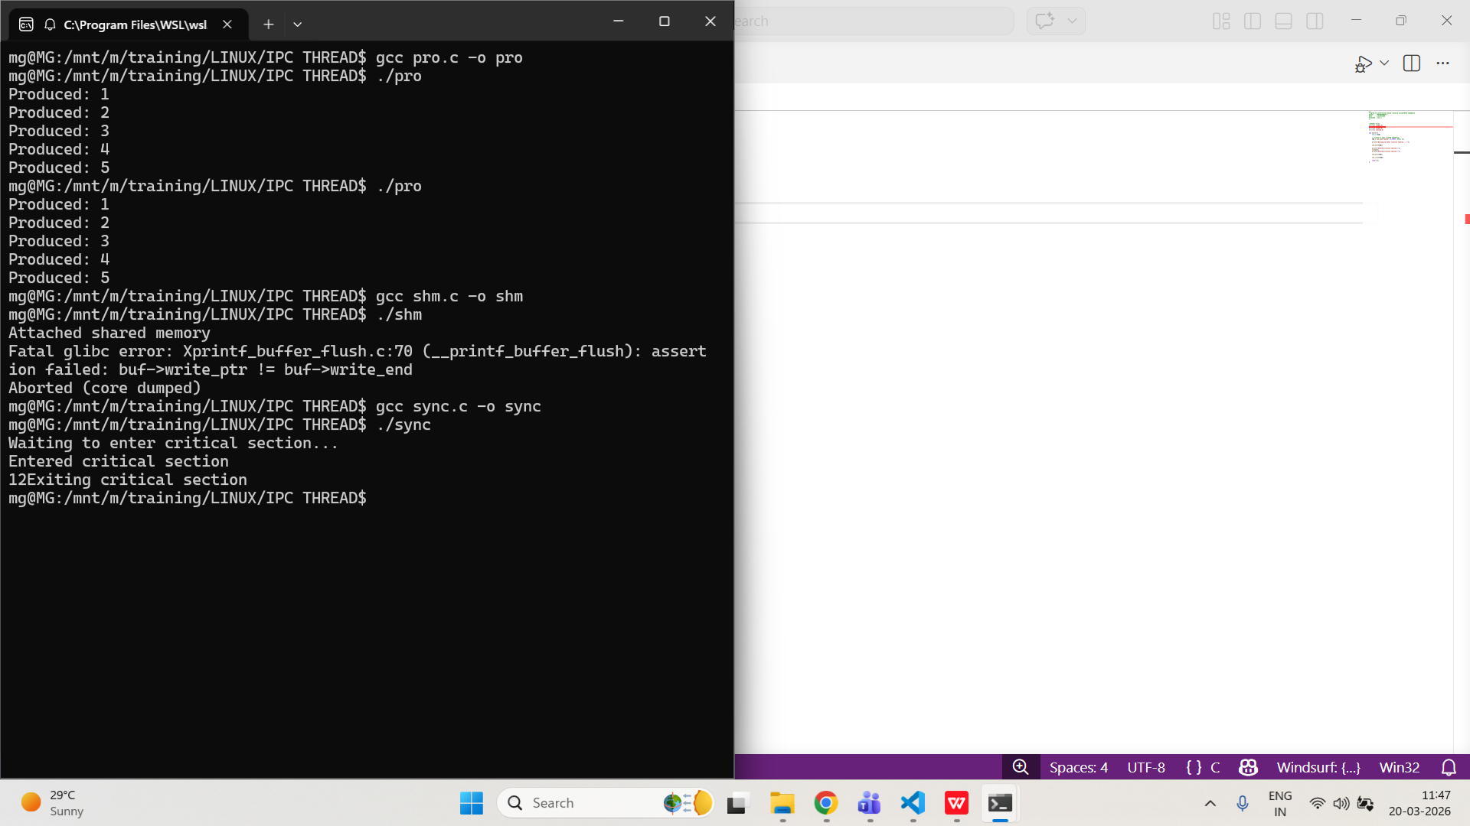
- Implement a program where a semaphore controls access to a critical section, allowing only three processes at a time.
PROGRAM:
/*
Program to allow only 3 processes in critical section
Author : MUTHUGANESH S
Date : 13/03/2026
Filename : lim.c
*/

//Header files
#include <stdio.h>
#include <semaphore.h>
#include <fcntl.h>
#include <unistd.h>

int main() {
//Create a named semaphore with an initial value of 3
sem_t *sem;

sem = sem_open("limitsem", O_CREAT, 0666, 3);

printf("Process %d waiting...\n", getpid());

sem_wait(sem);

printf("Process %d entered\n", getpid());
sleep(5);
printf("Process %d leaving\n", getpid());

sem_post(sem);

sem_close(sem);

return 0;
}
OUTPUT:
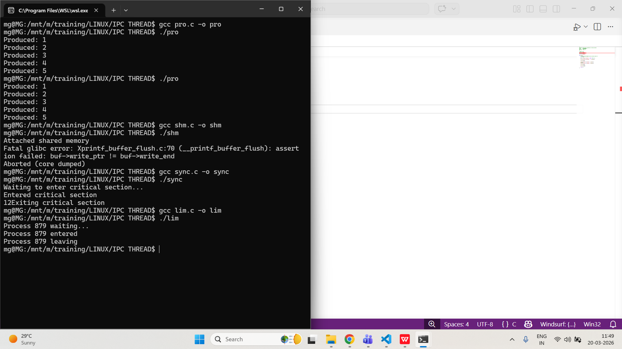
- Create a program that demonstrates the use of semaphore operations (sem_wait, sem_post) in a multi-threaded environment.
PROGRAM:
/*
Program to demonstrate sem_wait and sem_post with threads
Author : MUTHUGANESH S
Date : 13/03/2026
Filename : thr.c
*/

// Header files
#include <stdio.h>
#include <pthread.h>
#include <semaphore.h>
#include <unistd.h>

// Semaphore declaration
sem_t sem;

// Worker thread function
void* worker(void* arg) {
int id = *(int*)arg;

sem_wait(&sem);

printf("Thread %d in critical section\n", id);
sleep(2);
printf("Thread %d leaving\n", id);

sem_post(&sem);

return NULL;
}

int main() {
pthread_t t1, t2, t3;
int id1 = 1, id2 = 2, id3 = 3;

sem_init(&sem, 0, 1);

pthread_create(&t1, NULL, worker, &id1);
pthread_create(&t2, NULL, worker, &id2);
pthread_create(&t3, NULL, worker, &id3);

pthread_join(t1, NULL);
pthread_join(t2, NULL);
pthread_join(t3, NULL);

sem_destroy(&sem);

return 0;
}
OUTPUT:
